Experiment 3 - Exploratory Data Analysis (EDA) – Data Cleaning and Data Transformation

Aim:
To identify and handle missing values, duplicate records, outliers, and inconsistent data, and perform data transformation techniques such as normalization and encoding using Python Pandas on the Player dataset.

Procedure:
- Import the required Python libraries such as Pandas, NumPy, Matplotlib, and Scikit-learn.
- Load the Player dataset (Player.csv) into a Pandas DataFrame.
- Display the dataset information and identify missing values.
- Count the number of missing values in each column.
- Handle missing values by replacing numerical columns with their mean and categorical columns with their mode.
- Identify duplicate records and remove them.
- Detect outliers in numerical columns using the Interquartile Range (IQR) method.
- Visualize outliers using a box plot.
- Normalize numerical features using Min-Max Scaling.
- Encode categorical variables using Label Encoding.
- Perform One-Hot Encoding on another categorical feature.
- Display the cleaned and transformed Player dataset. This mirrors the structure of the original Experiment 3 while replacing the Space Mission dataset with your Player dataset.

Code:
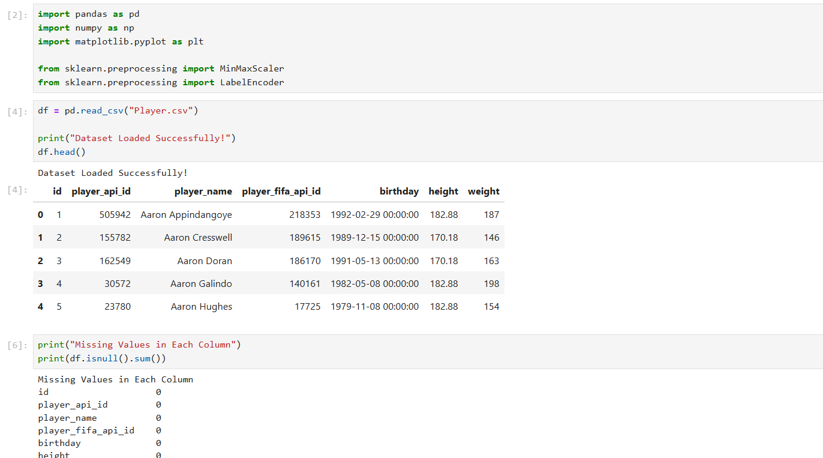
- Import necessary libraries and read the dataset
- Check if the dataset has missing values
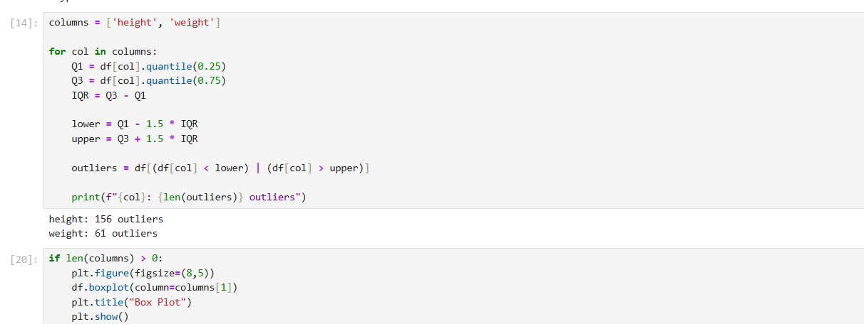
- Detect number of Outliers Using IQR
- Show the weight columns outlier in boxplot

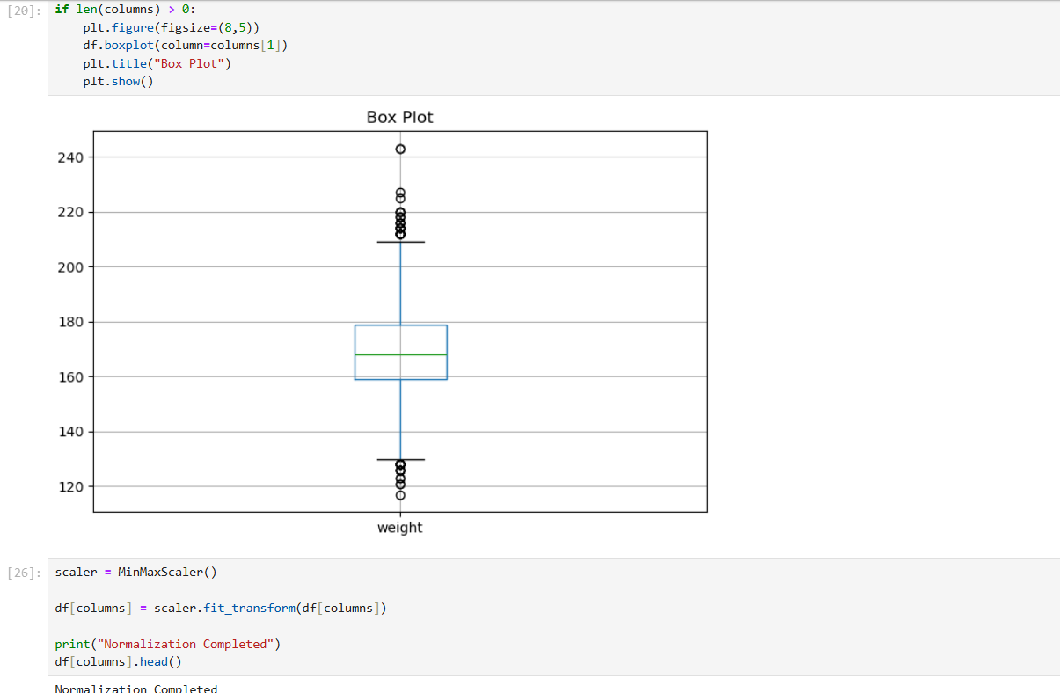

- Normalize Numerical Features of height and weight columns
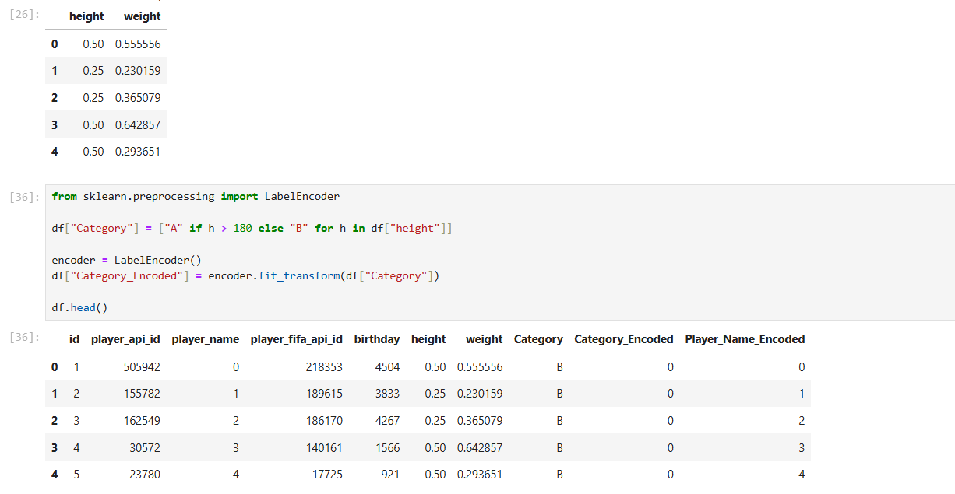

- Perform Label Encoding on a sample categorical column based on player height

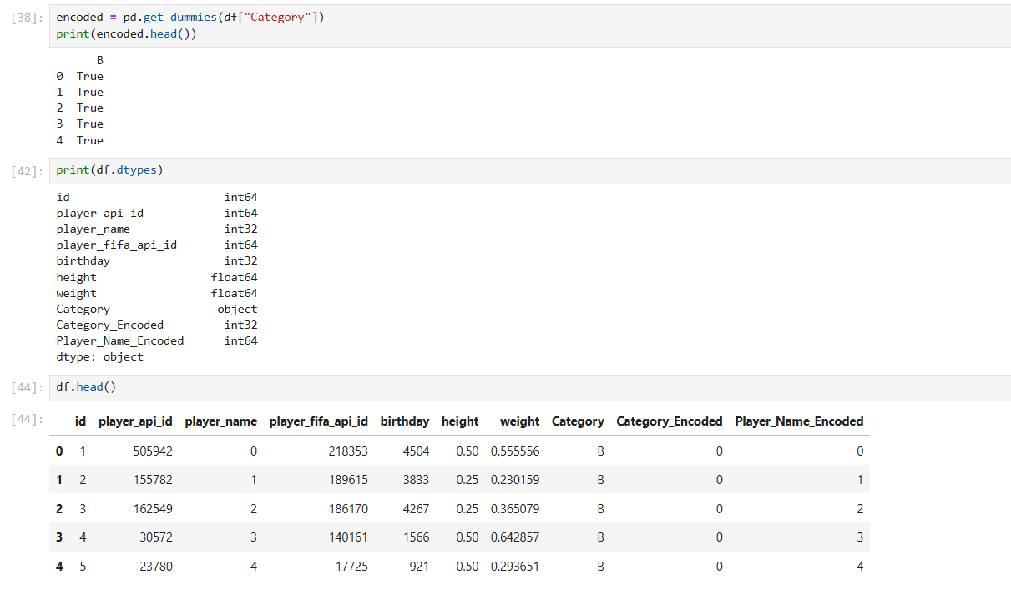

- Perform One-Hot Encoding on the sample categorical column
- Display the data types of all columns in the dataset
- Display the cleaned and transformed Player dataset

